2023-11-04 - Handout – Patterns of DP

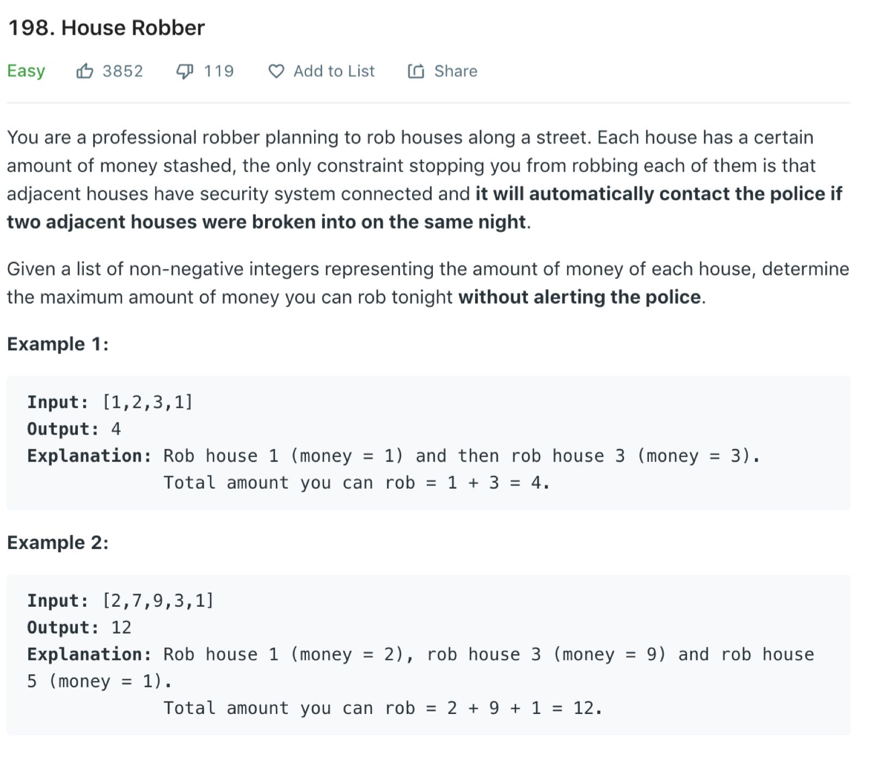**Linear Dynamic Programming:**

**Grid Dynamic Programming**

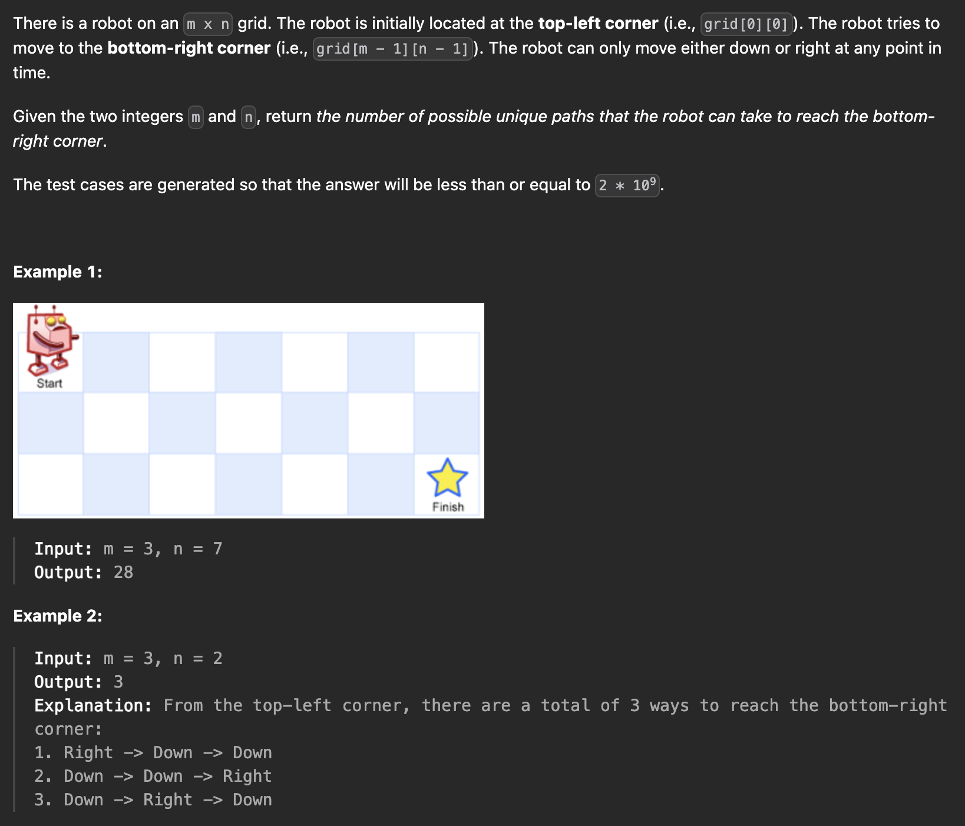

Caption

**0/1 Knapsack**

Caption

**Knapsack Unbounded**

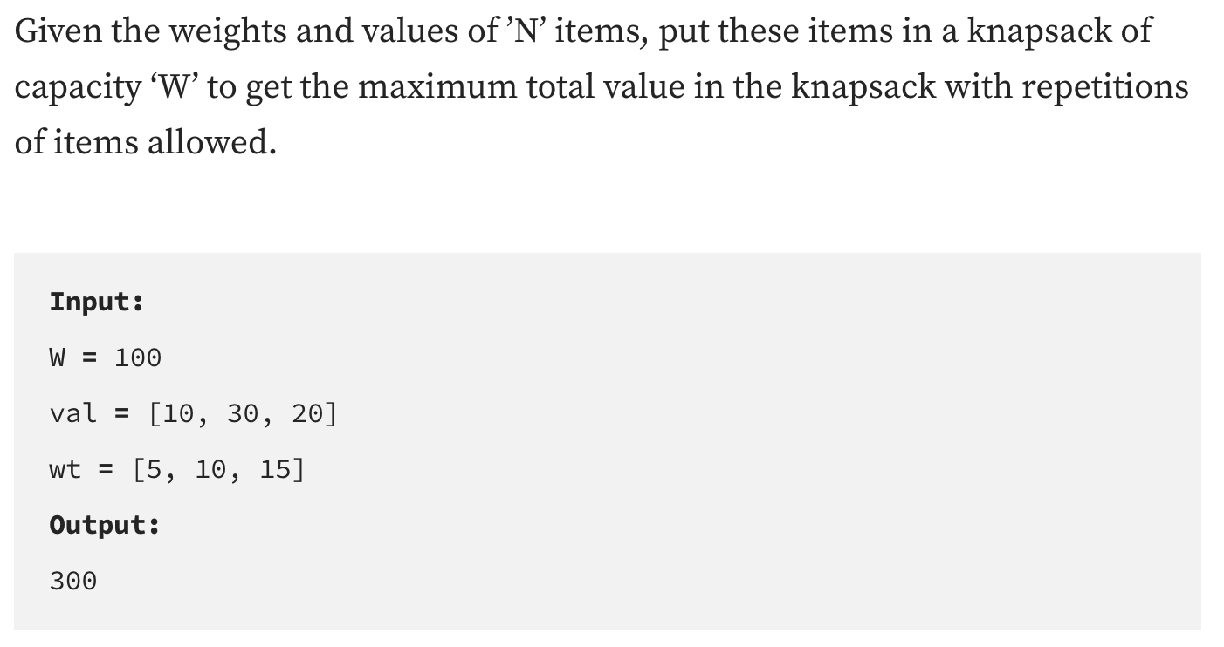

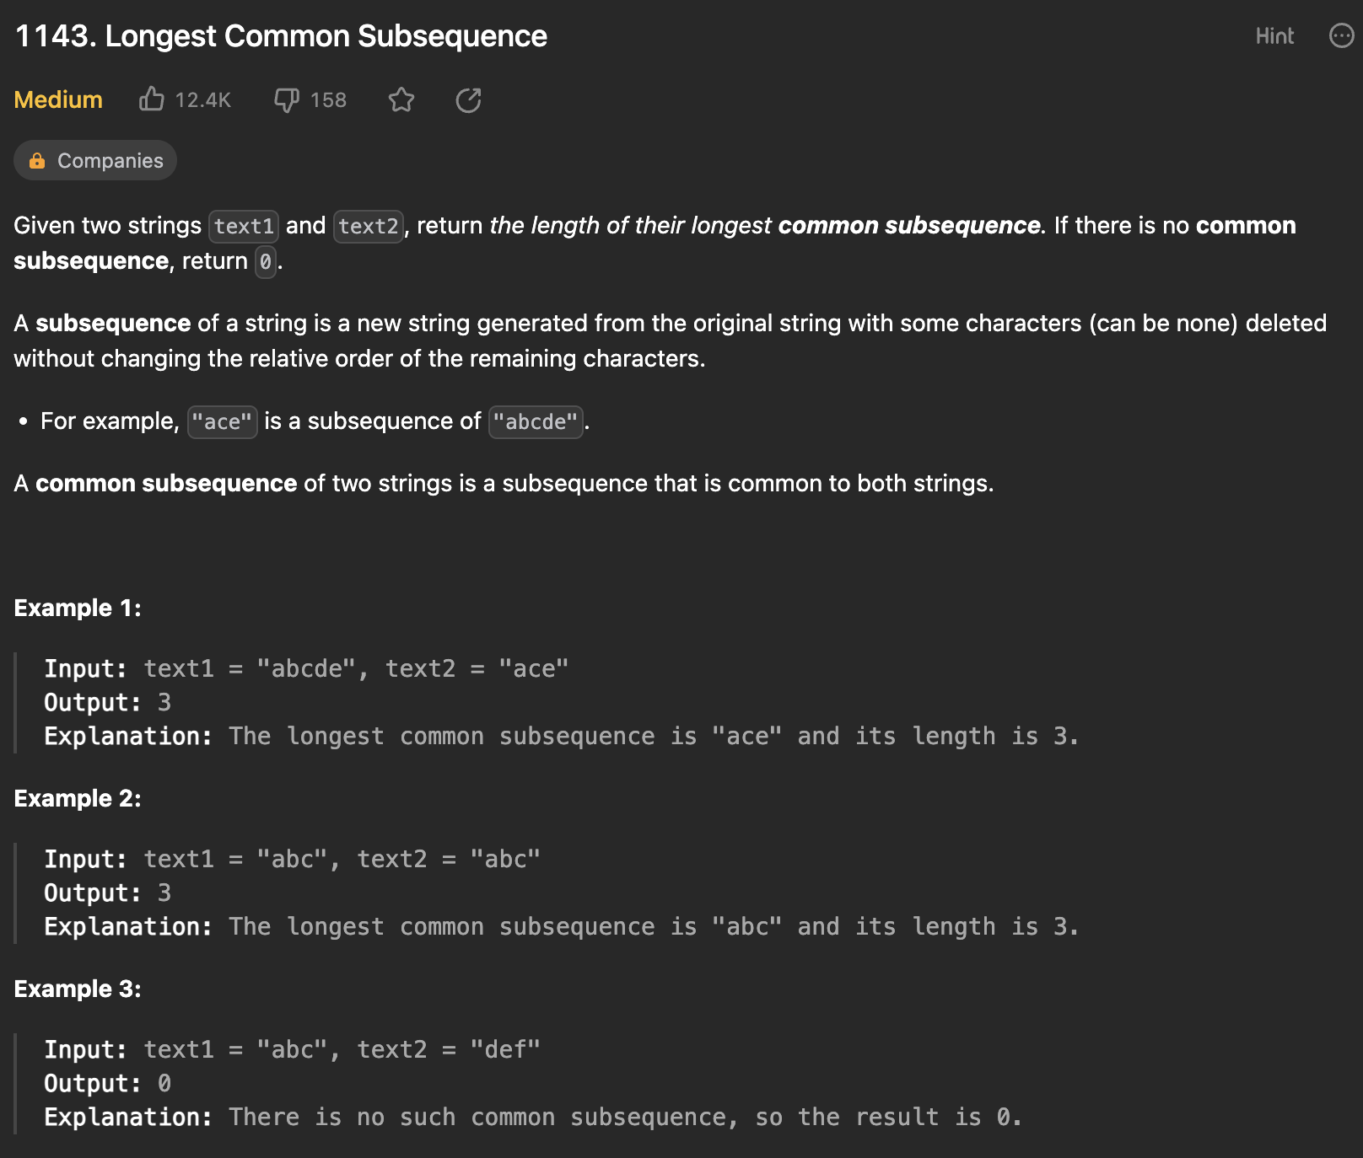

Caption